ASSIGNMENT

1.Create a blog or website using Blogspot and WordPress. Customize the theme design and post new article with 500 words.

LINK:<https://wordpress.com/post/furnidotblog.wordpress.com/7>

2. Create a New Facebook Business Page and post one

social media poster for your brand.

LINK:[https://www.facebook.com/AKfurnitureWorld1/](https://www.facebook.com/lkmakeupstudio/)

3. Create and design a social media advertisement poster

using canva.

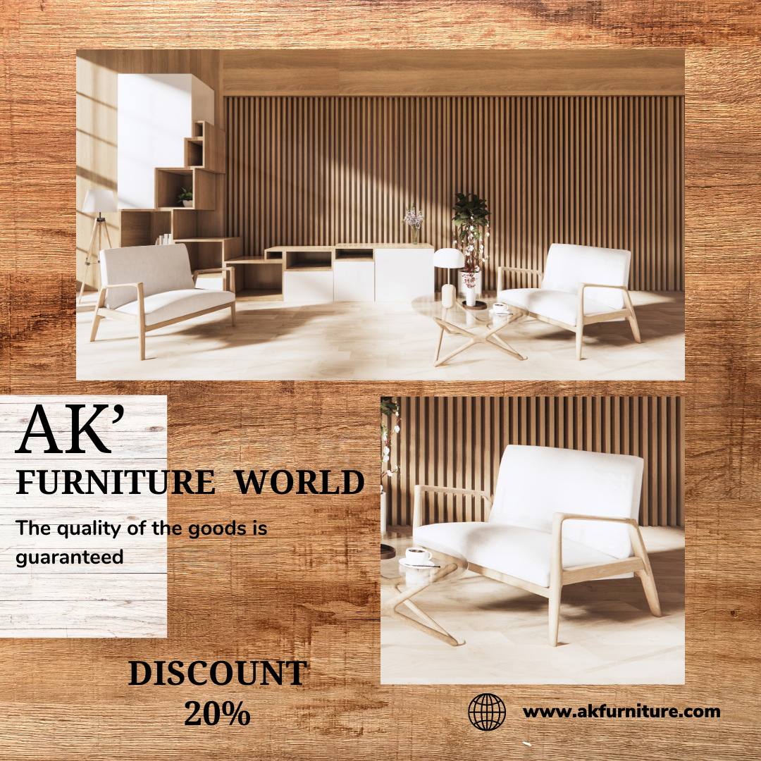

4. Create email newsletter design using MailChimp or canva

tool.

